**Terna Engineering College**

**Computer Engineering Department**

Program: Sem VIII

**Course: Human Machine Interaction (HMI)**

**Faculty:** Prof. Vishwajit Gaiikwad, Prof. Umesh B Mnatale, Prof. Deepti Omen

**LAB Manual**

**PART A**

(PART A : TO BE REFFERED BY STUDENTS)

**Experiment No.05**

|  |  |
| --- | --- |
| **A.1** | **Aim:** |
|  | Design an interface for any machine which you found troublesome to use and want to change its interface like automatic washing machine, microwave oven etc. |
|  |  |
| **A.2** | **Prerequisite:**   1. Knowledge about your client and his various characteristics. 2. Knowledge of user interface and various parameters of user interface |
|  |  |
| **A.3** | **Outcome:** |
|  | **After successful completion of this experiment students will be able to**   1. analyze existing complex interface designs and suggest modifications based on user centric interfaces 2. ApplyHMI Principles to design good GUI. |
|  |  |
| **A.4** | **Theory:-** |
|  | * **Things to focus for UI design:**   To achieve effective interface design, a designer must first gain an in-depth understanding of the target user, as well as the goals of using the machine or product. The best interface designers take time to gain an understanding of not only the identity of the user but also user skill level, possible environmental effects on the machine, and the most important primary and secondary functions for the user.  The interface must be easy to learn and operate for the end user, as well as consistent. This is one of the most challenging aspects of interface design for engineers. One of the most important things about interface design to remember throughout the design and engineering process is that the interface should be simple to understand and easy to use on the first use with minimal training and onboarding  It’s also important to avoid defining the target user group too broadly. This often leads to missing the distinct needs of various subgroups who are likely to use the machine. Always consider the distinct nuances and variations among these end user subgroups, as well as how each target end user will use the product. Aim to make key functions as intuitive as possible for each of these users. |
| **A.5** | **Procedure:**   1. All the machine interfaces are designed by manufacturer. All users are not comfortable with them. 2. Think of any trouble some machine which you experienced or found across through some one 3. List out the troubles faced by the user in operating particular machine interface 4. Design an interface for the same machine to improve operability of the machine 5. **Example:**   Interface for washing machine |

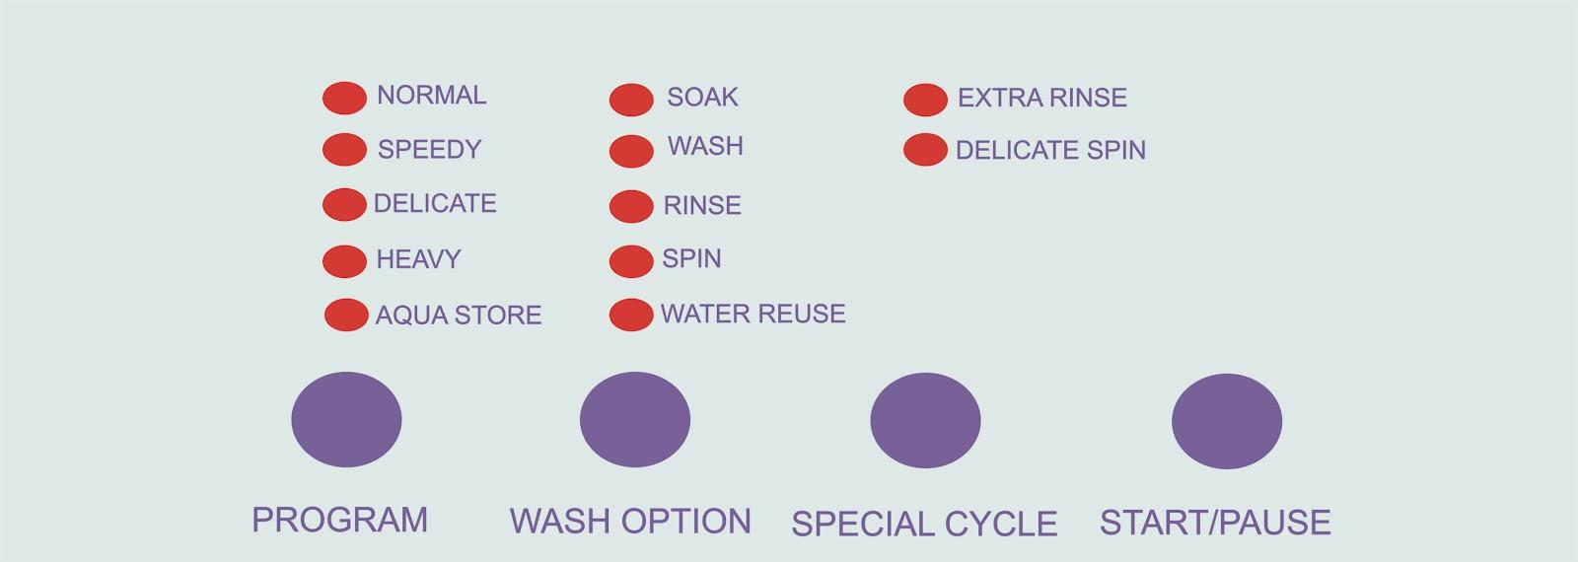

**PART B**

(PART B: TO BE COMPLETED BY STUDENTS)

***(Students must submit the soft copy as per following segments within two hours of the practical. The soft copy must be uploaded on the ERP or emailed to the concerned lab in charge faculties at the end of the practical in case the there is no ERP access available)***

|  |  |
| --- | --- |
| Roll No.: 62 | Name: Atharva Deshmukh |
| Class: BE A | Batch: A3 |
| Date of Experiment: | Date of Submission: |
| Grade: |  |

|  |  |
| --- | --- |
| **B.1** | **Machine selected for the interface design:** |
|  | **(**Write Name of the machine that you selected for interface design and why)  Fire tv remote as most of the remotes don't have volume control options so the customer has to use more than one remote everytime to operate the TV. |
| **B.2** | **Choice of User Interface Elements:**  (List of various UI elements used.)  **Buttons, scrollview, toggle** |
| **B.3** | **User Interface Designs:**  **(**Add screen snapshots of new interface design of the machine.)  import * as React from "react"  import { Frame, addPropertyControls, ControlType } from "framer"  // Learn more: https://framer.com/api  export function FiretvRemote(props) {  const { tint, onTap } = props  return (  <Frame background="none" size="100%">  <Frame  size={150}  radius={25}  center={true}  background={tint}  style={{  maxWidth: "100%",  maxHeight: "100%",  }}  onTap={onTap}  whileHover={{  scale: 1.25,  rotate: 90,  background: "#07F",  }}  />  </Frame>  )  }  FiretvRemote.defaultProps = {  height: 200,  width: 200,  tint: "#09F",  }  addPropertyControls(FiretvRemote, {  tint: {  title: "Tint",  type: ControlType.Color,  },  onTap: {  type: ControlType.EventHandler,  },  })  2.  import { Override, Data, Color } from "framer"  const data = Data({  background: Color("#09F"),  })  export function Rotate(): Override {  return {  animate: { rotate: 90 },  transition: { duration: 2 },  }  }  export function Hover(): Override {  return {  whileHover: {  scale: 1.05,  },  }  }  export function RandomColor(): Override {  return {  animate: {  background: data.background,  },  onClick: () => {  data.background = Color.random()  },  }  }  Output |
|  |  |
|  |  |
| **B.4** | **Comparison:**  **(**Compare the existing one with proposed one**)** |
|  |  |
| **B.5** | **Explain the importance of Human Centered Design?**  Human-centered design is a powerful way to understand evolving behaviors, preferences, and pain points and to focus efforts in the right places in the right ways. By unlocking the user’s perspective, designers can build solutions that work well and work widely in our new reality—whatever that ultimately looks like. |

**B.6 Conclusion:**

**(**Write appropriate conclusion based on application designed.)

With the new design update customers have easy access to volume controls.

**\*\*\*\*\*\*\*\*\*\*\*\*\*\*\*\*\*\*\*\*\*\*\*\*\*\*\*\*\*\*\*\*\*\*\*\*\*\*\*End\*\*\*\*\*\*\*\*\*\*\*\*\*\*\*\*\*\*\*\*\*\*\*\*\*\*\*\*\*\*\*\*\*\*\*\*\*\*\*\*\*\*\***